Q1. Write a java program to convert given amount into smallest possible bank notes

Enter Amount: 1388

Notes of 100: 13

Notes of 50: 1

Notes of 20: 1

Notes of 10: 1

Notes of 5: 1

Notes of 2: 1

Notes of 1: 1

import java.util.Scanner;

class Bank{

public static void main(String args[]){

int a,rm,n;

Scanner sk=new Scanner(System.in);

System.out.println("Enter Any Number ");

a=sk.nextInt();//1388

n=a/100;

System.out.println("Notes of 100 : "+n);

rm=a-n\*100;

n=rm/50;

System.out.println("Notes of 50 : "+n);

rm=rm-n\*50;

n=rm/20;

System.out.println("Notes of 20 : "+n);

rm=rm-n\*20;

n=rm/10;

System.out.println("Notes of 10 : "+n);

rm=rm-n\*10;

n=rm/5;

System.out.println("Notes of 5 : "+n);

rm=rm-n\*5;

n=rm/2;

System.out.println("Notes of 2 : "+n);

rm=rm-n\*2;

n=rm/1;

System.out.println("Notes of 1 : "+n);

}

}

Q2. Explain Increment(++) and decrement(--) operator in java programming?

Ans:

In case of Increment operator value of its operands increase by 1

Example:

int a;

a=45;

++a;

OR

a++

In case of decrement operator value of its operands decrease by 1

Example:

int a;

a=45;

--a;

OR

1. -;

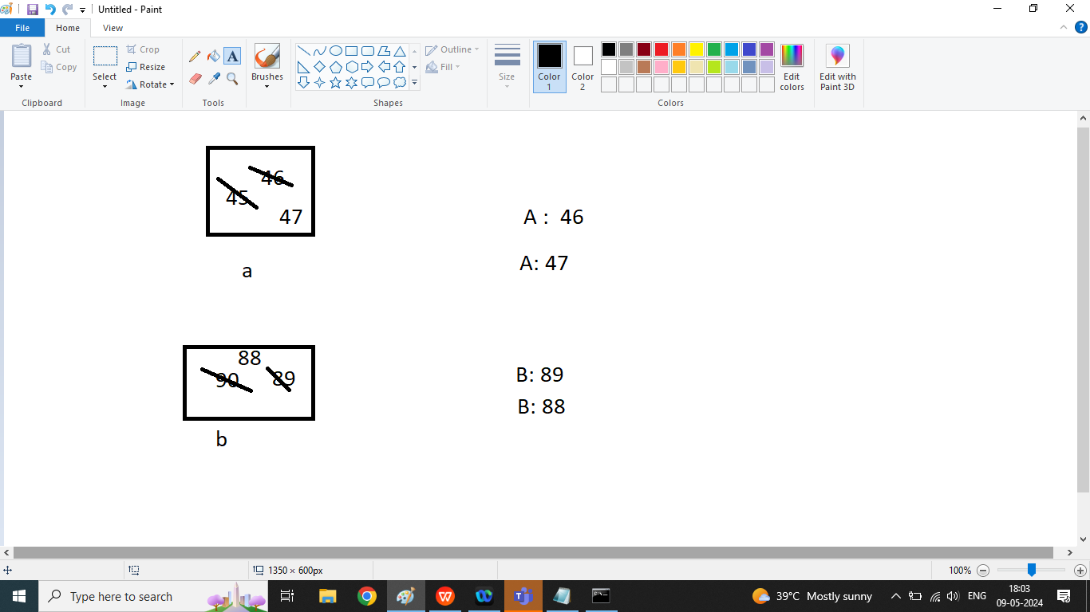

class A1{

public static void main(String args[]){

int a,b;

a=45;

b=90;

++a;

System.out.println("A : "+a);

a++;

System.out.println("A : "+a);

b--;

System.out.println("B : "+b);

--b;

System.out.println("B : "+b);

}

}

Q2. Explain Pre-Increment and Pre-Decrement in java programming?

Ans:

Pre-Increment : In case of Pre Increment first increase the value of its operands by 1 then we can used this value in the expression (incremented value)

Example:

int a,b;

a=10;

b=++a;//a=11

Pre-Decrement : In case of Pre Decrement first decrease the value of its operands by 1 then we can used this value in the expression (decremented value)

Example:

int a,b;

a=10;

b=--a;

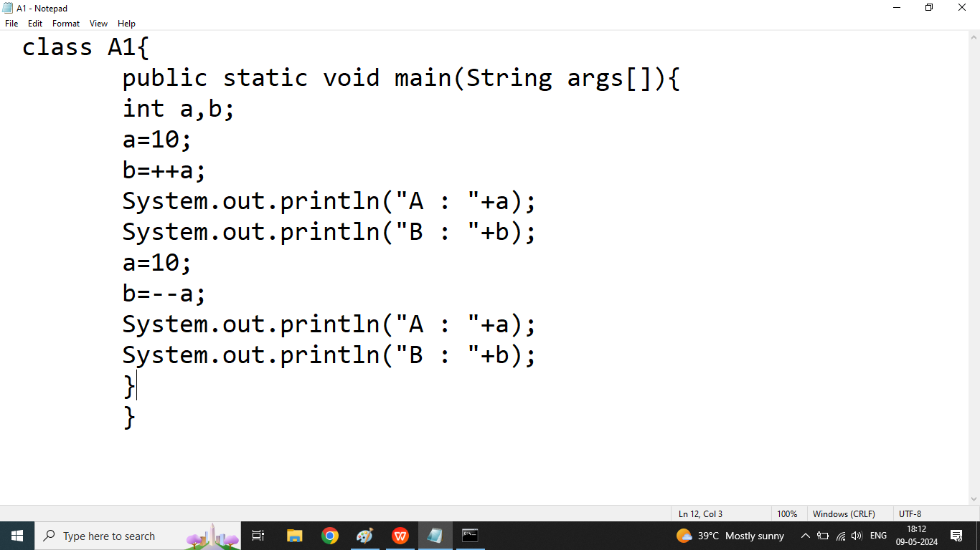

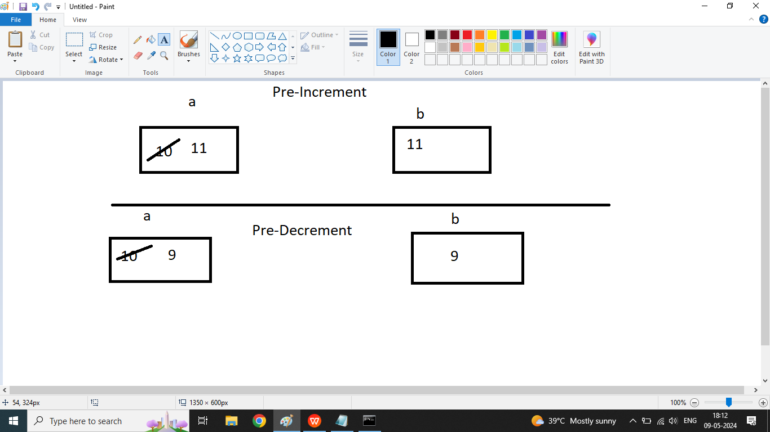

Q4. Explain post Increment or post decrement operator in java programming?

Ans :

Post Increment : In case of Post Increment First we use original value of its operand in the expression, after complete execution of the expression then value of operand will increase by 1 and we cannot use incremented value in the expression

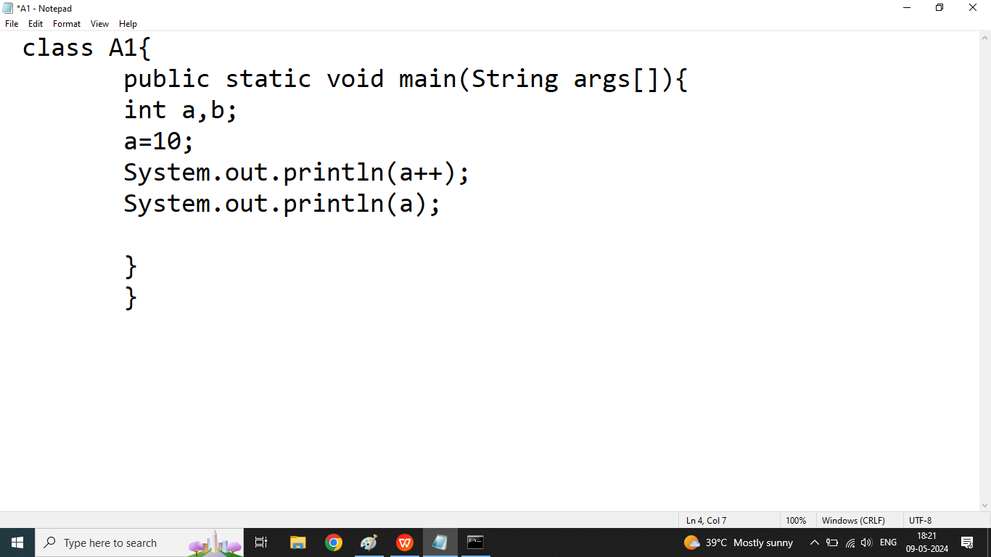

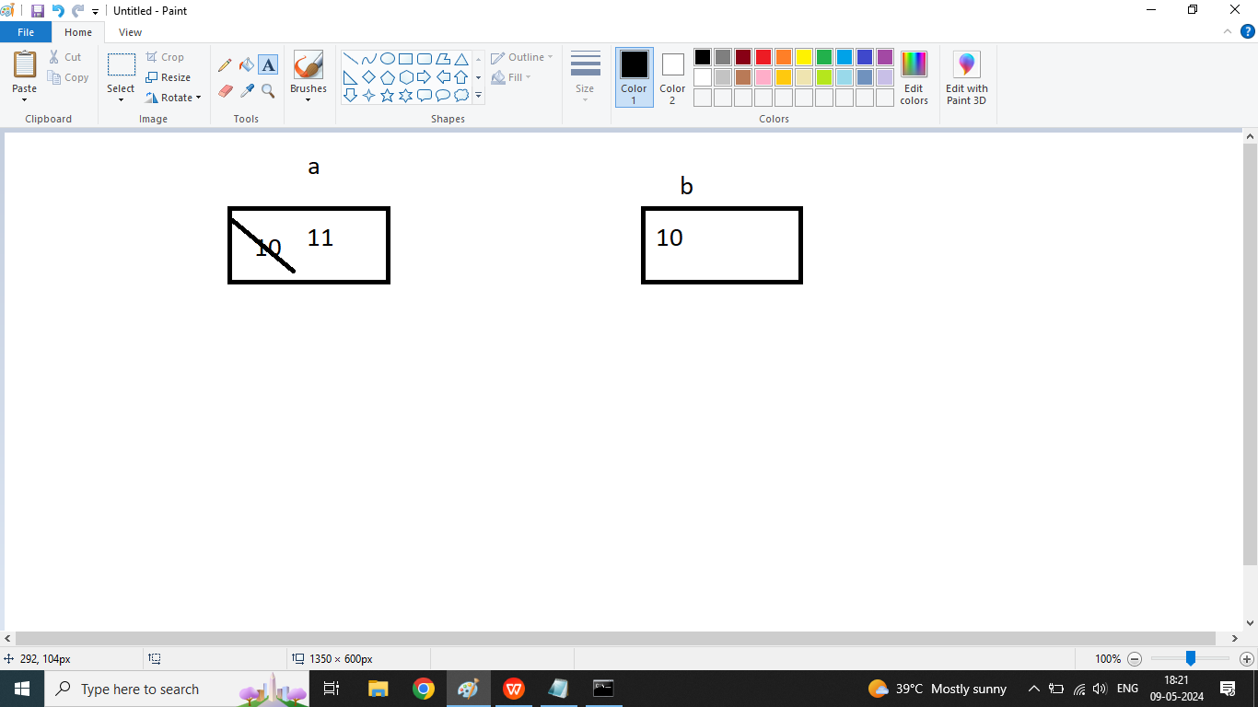

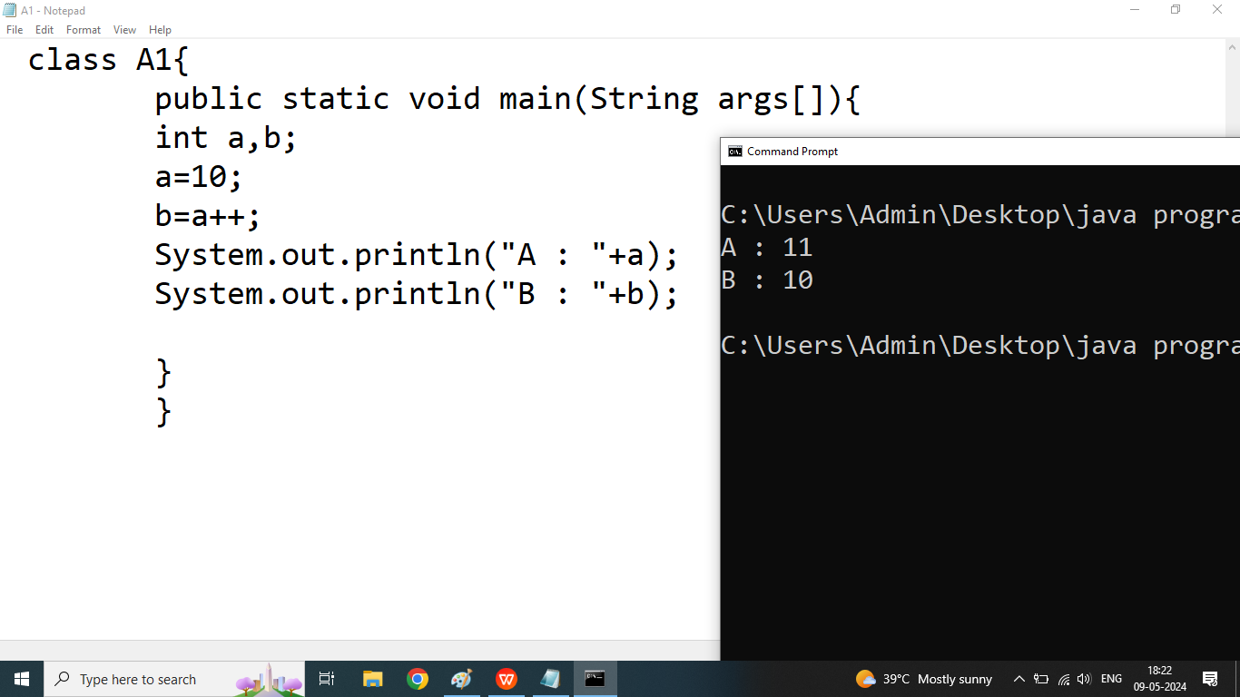

Post Decrement : In case of Post Decrement First we use original value of its operand in the expression, after complete execution of the expression then value of operand will decrease by 1 and we cannot use decremented value in the expression

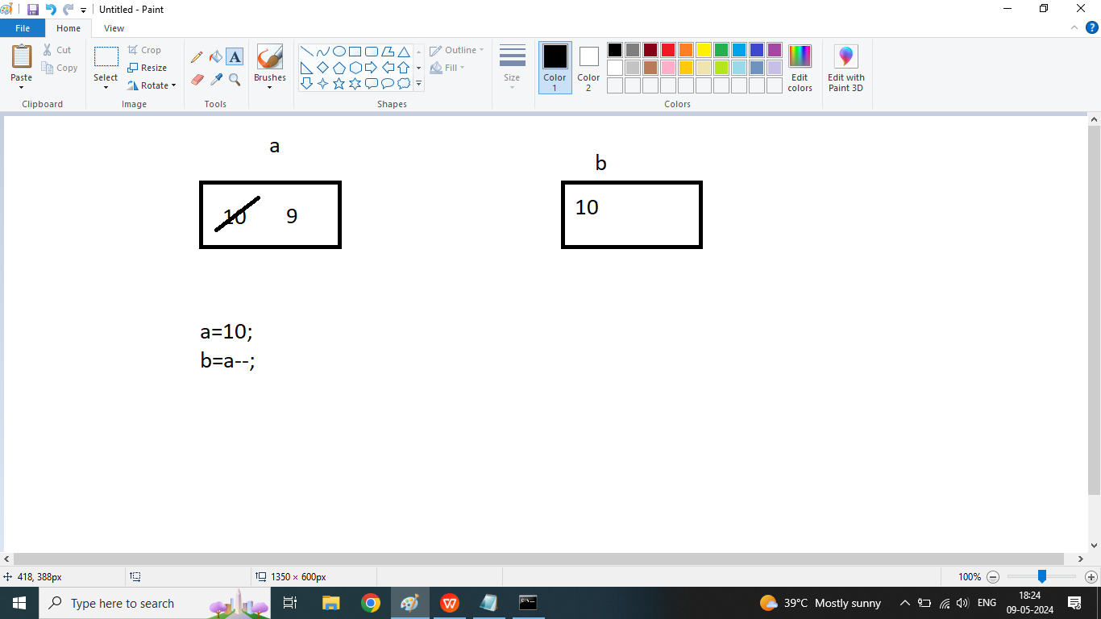

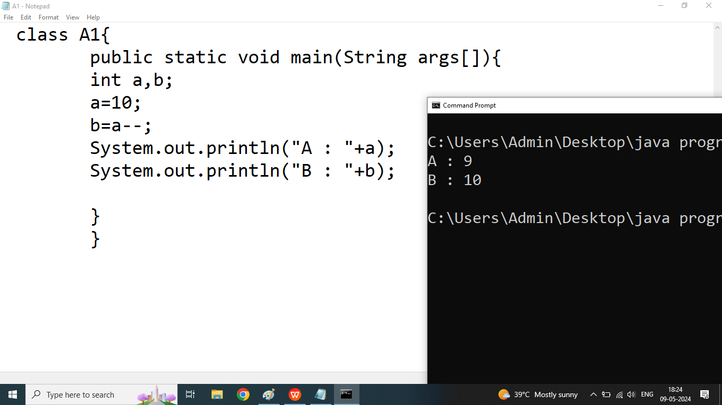

Q5. What will be the output of following program?

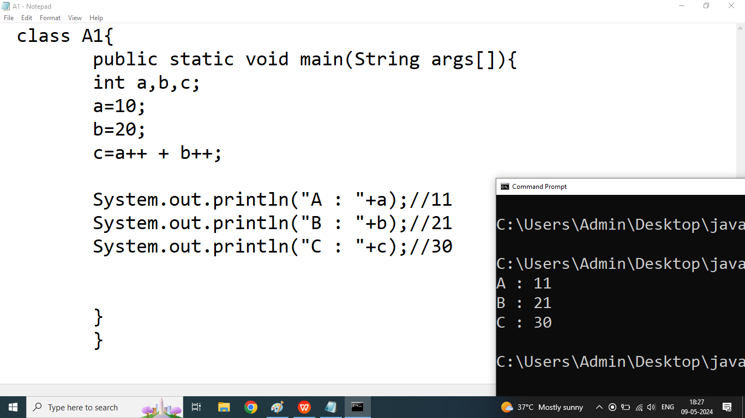

Q6. What will be the output of following program?

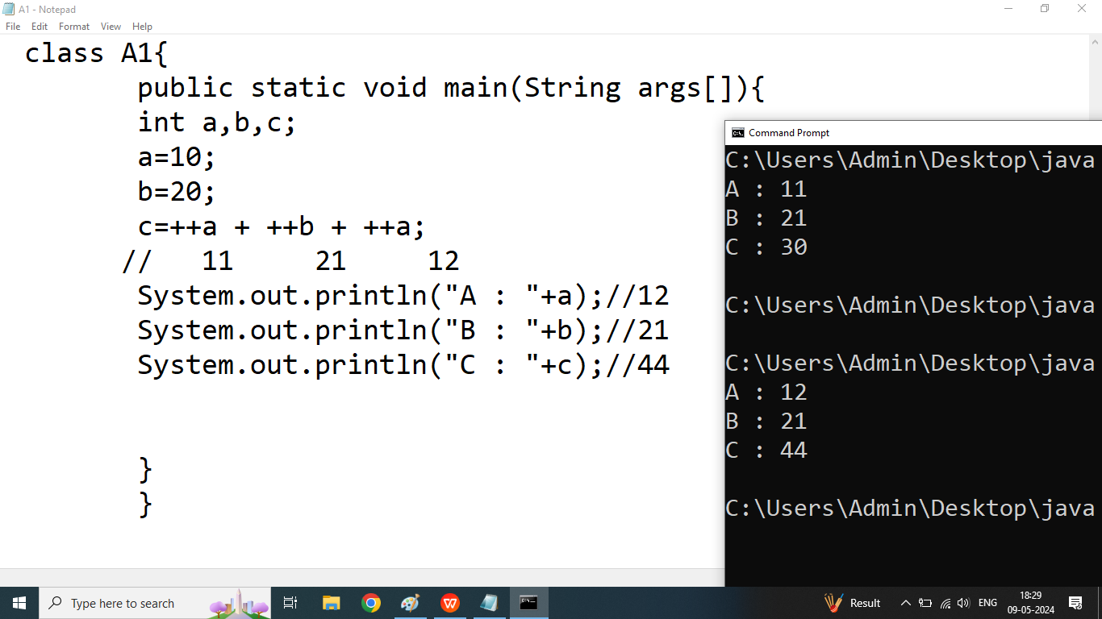

Q2. Explain Relational Operator or Conditional Operator in java programming?

Ans: if we want to compare something or define some condition then we should go for Relational operators

We discuss following conditional Operators

1. >
2. <
3. >=
4. <=
5. ==
6. !=

Note: Result of All Relational operators are true or false.

